
Dhaka International University

Assignment details:
Assignment Topic : Introduction to Files
Assignment No :01
Assignment Title : Introduction to Files
Course Code : 0613-201

Submitted By: | Submitted To:
Name: S M NABIL AUSAF  ROLL: 01  Reg No : CS-D-91-23-124492 | Prof. Md. Abdul Based

Date of Submission:18.01.25

Introduction to Files
What is a File?
A file can be defined as a container that holds data on a computer or storage device. Files can contain text documents, images, audio, video, and executable programs among other types of data. Files are the medium through which both humans and machines have their interaction with data. They can be opened, edited, and saved in many different formats depending on the type of data they contain.
Why are files so important?
Files serve several fundamental purposes:
- Permanent Storage: Unlike temporary data, which resides in RAM, a file persists data to storage devices, such as a hard drive, SSD, or even cloud storage when the system is off.
- Easy Access and Modification: Files are entities that allow either the user or software programs to retrieve, modify, and update information contained therein. Because of this, a file becomes so flexible and can be used in all kinds of purposes.
- Data Organization: Files organize data in a well-structured manner.

For example: text files contain data in structure, while picture files maintain graphics data. All this systematic storage enables the retrieval of any type of information easily.
- Security and Backup: Files can be encrypted in order to secure sensitive information and can also be backed up so that, should a system failure or security breach occur, data would not be lost.
Types of Files
There are two major types of files:
1. Text Files: These contain readable text and are easily opened and modified with the use of text editors. Examples include .txt, .csv, .xml, and .html files.
2.Binary Files: These are files containing data in a non-readable format, usually for usage by programs or operating systems. They store images, videos, or program executables with the likes of file formats.exe,.jpg,.mp3,.mp4, and.zip.

File Organization and Structure
File Organization Methods
The various ways of filing allow systems to manage enormous data with ease:
1.Sequential Files: These files store data in a linear sequence, and hence, they are relatively easy to process sequentially. However, access to any particular data may be time-consuming if the file is big, such as transaction logs.
2.Indexed Files: An index is used to locate records, and hence, access time is drastically reduced. These are widely used in database systems where access to any particular data is required very fast.
3. Direct Access Files: These are files that allow access to any record directly, such as those stored on hard disks or SSDs. This access is done with utmost speed and randomly.
File Extensions and Formats
Files are available in several formats, each serving a particular purpose:
- Document Files: These are files used to store documents or writings. Examples include.docx for Word documents and.pdf for Portable Document Format.
- Image Files: These are used to store images. Examples include.jpg and.png.
- Audio Files: Store sound data (e.g., .mp3, .wav).
- Video Files: Store moving visual data (e.g., .mp4, .avi).
- Executable Files: Used to run programs and applications (e.g., .exe, .bin).
File Directories and Paths
- Absolute Path: Specifies the complete location of a file, starting from the root directory.
For example: C:\Users\Documents\file.txt specifies the full path on a Windows system.
- Relative Path: It is the path of a file concerning the current working directory.
For example: /Documents/file.txt would be a file in the Documents folder concerning the current directory.
File Operations
Basic File Operations
Following some of the usual operations performed on files:
1. Creation of a file: It is the very first step in the handling of files. A new file is created for the purpose of storing data.
2. Opening of a File: The file needs to be opened if any application wants to read or write into the file.
3. Reading from a File: Once opened in read mode, the application can then access the data contained in the file and perform the desired operations on that data.
4. Writing to a File: It opens in write mode when new data needs to be written or if already available data needs modification.
5. Closure: The Closure of the file saves all the changes and frees the resources.
6. Deletion: The file is deleted from the storage permanently.
File Handling in Different Programming Languages
Programming languages provide various built-in functions for handling files. Following is how a few popular languages handle files:
- C Language: The programming language C allows file operations with functions like fopen(), fclose(), fread() and fwrite().

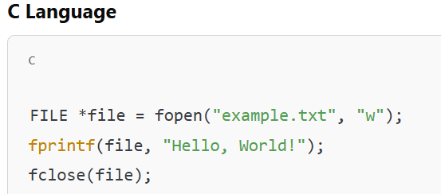

- Java: Java has the classes File, FileReader, and FileWriter for manipulating files. Java's try-catch mechanism assists in handling file-related errors.
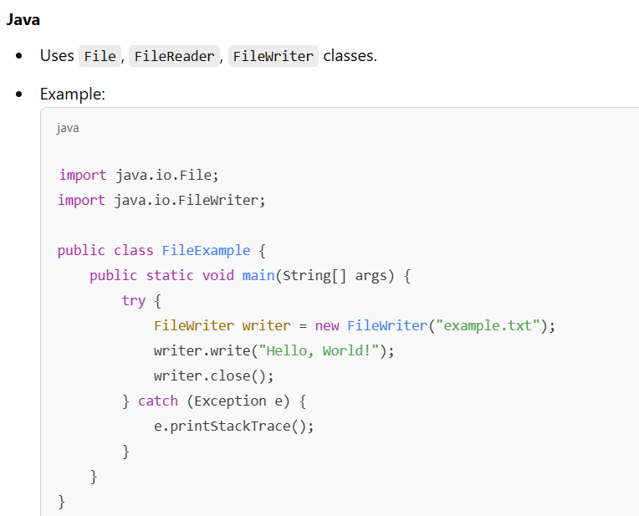

- Python: Python uses the open() function to open files; methods such as read() and write() enable data reading and writing, respectively.
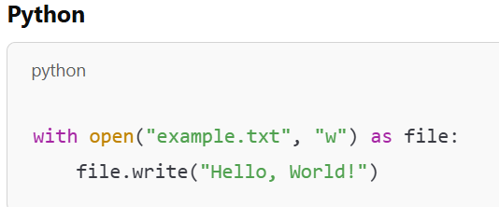

Managing and Storing Files
File System Types
File systems are programs that control how data is stored and retrieved:
- FAT: The older of the two file systems, generally used in USB drives and memory cards.
- NTFS: This is used by Windows because it is more reliable, supports large files, and has extra security features.
- EXT: Extended File System is generally used on Linux environments. File Storage Methods There are several ways in which files may be stored:
1​. Local Storage: Files stored directly on your computer's hard drive or SSD. This is the most common method for personal data storage.
2​. Cloud Storage: Services such as Google Drive, Dropbox, and iCloud store files on remote servers that one can access from anywhere provided there is access to the internet.
3​. Network Storage: Multiple computers share files via a network using devices like Network Attached Storage (NAS) or Storage Area Networks (SAN).
File Compression Techniques
- Lossless Compression: This compression technique reduces the size of the file without losing any data. It is used with text files and databases. Examples include.zip, .rar, and.tar.
- Lossy Compression: It reduces the size of the file by losing some data. It is used in the case of multimedia files, images, and audio. Examples include.jpeg,.mp3, and.mp4.
File Security and Protection
Common File Security Threats
Files can be vulnerable to various threats:
- Virus and Malware: Programs that corrupt, steal, or destroy data in files.
- Unauthorized Access: Files may be viewed by hackers or other unauthorized personnel.
- Data Corruption: Files can get corrupted due to power failure, hardware malfunction, or software bugs.
File Protection Techniques
1. Encryption: It protects the content of the file by converting it into unreadable data through some kind of cryptographic algorithm.
2. Password Protection: It provides access to the file only on inputting a password.
3. File Permissions: Assigns permissions of reading, writing, and executing to users and groups so that the given file can be accessed or altered by only those who are allowed.
Legal Aspects of File Management
- Data Privacy Laws (GDPR, CCPA): These are laws ensuring that personal data is handled securely and that users' privacy is guaranteed.
- Intellectual Property Rights: Copyright, patents, and trademarks protect files that contain creative works, inventions, or proprietary information.
Additional Knowledge of Modern File Systems and Cloud Storage
Modern File Systems
With the advancement in technology, file systems have also been upgraded to meet modern hardware and performance requirements of today's operating systems:
- APFS (Apple File System): Designed for macOS and iOS, it is optimized for flash and SSD storage, offering better security, data integrity, and efficiency.
- ReFS (Resilient File System): Developed by Microsoft for servers, ReFS focuses on high availability and data resilience with error-correcting features.
- ZFS, used in too many enterprise systems, guarantee advanced means of data integrity, large storage, and redundancy.
Cloud Storage
Cloud storage is one such modern trigger for file management:
- Google Drive: Allows 15GB of free storage and seamless sharing, along with collaboration.
- Dropbox: Known for the synchronization of files across devices, Dropbox offers personal and business plans.
- OneDrive: Cloud storage by Microsoft integrates with Office 365, hence is widely used by business users.
Advantages and Disadvantages of Cloud Storage
Advantages:
- Accessibility from any device connected to the internet.
- Enhanced security with encryption and multi-factor authentication.
- Easy sharing and collaboration across teams.
Disadvantages:
- Dependence on an internet connection.
- Privacy concerns due to third-party server storage.
- Subscription fees for additional storage space.

Conclusion
The modern way of computing and storing data digitally relies on files. Being able to understand different types of files, file systems, and operations means that we are in a position to manage and protect the data efficiently. It is very important to ensure the integrity of data in files against threats like malware and unauthorized access, among others. Working with files is a basic skill in computer science, software development, and data management.

